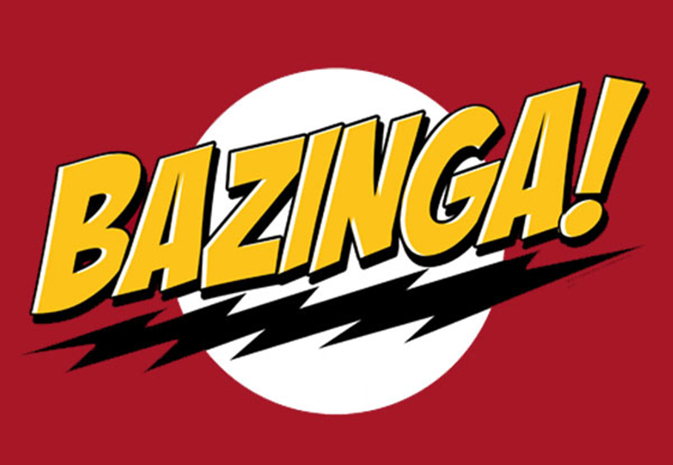

Track Controller Bug Report

April 26, 2012

Zhipeng Liu

**1 Introduction**

The bug report contains the bugs from TrackController module made by Zhipeng Liu (aka Gilbert).

**2 Bug List**

**2.1 Switching failure at the top right corner**

**Reproduce:** Start the simulation, and the train will stop at the second switch.

**Analysis:** This may be caused by the flaws in the track layout xml file. I tried to switch it manually and also tried Sean’s TrackController module, but it still doesn’t work. So for now, the train will stop before the second switch.

**2.2 Second train doesn’t move**

**Reproduce:** Start the simulation, when the first train leave the first block where it spawns, click that block and spawn another train. The second train will not move.

**Analysis:** This is caused by the defects in the algorithm when updating track block authorities. To ensure two trains are not close enough to crash, several blocks previous and next to the current block where the train presents will be marked as red. The spawning block may be effected by this safety measure.